MATLAB CODE FOR LAB 9:

num=[1 7];
den=conv(conv([1 0],[1 5]),conv([1 15],[1 20]));
subplot(2,1,1)
rlocus(num,den)
axis([-22 3 -15 15])
zeta=0.7;
wn=1.8;
sgrid(zeta,wn)
[kd,poles]=rlocfind(num,den);
[numcl,dencl]=cloop((kd)*num,den)
subplot(2,1,2)
step(numcl,dencl)

RESULTS:
selected_point =

-3.1315 + 5.8537i

numcl =

1.0e+003 *

0 0 0 1.3737 9.6161

dencl =

1.0e+003 *

0.0010 0.0400 0.4750 2.8737 9.6161

GRAPH:

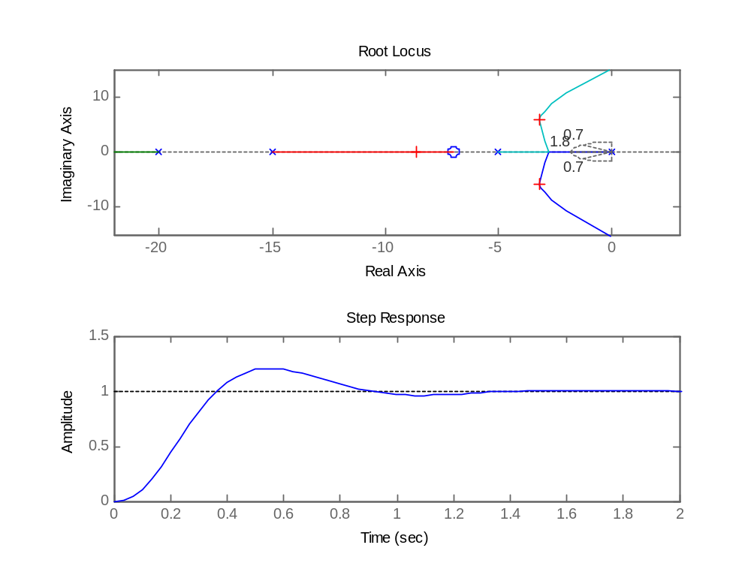

MATLAB CODE FOR LAB 10:

num=[0 0 0 1 1]
den=[1 4 6 4 0]
w=100
subplot(2,1,1)
[mag,phase,w]=bode(num,den,100)
n=[0.1:1000]
w=logspace(0.1,1000,5500)
bode(num,den,w)
subplot(2,1,2)
semilogx(w,20*log10(mag))
[Gm,Pm,wcp,wcg]=margin(num,den)

GRAPH:
